Media release

Despite the war, Ukraine holds strong as a   
Top 5 Organic Exporter to the EU

Ukraine will again be present at this year’s Biofach, the world’s leading trade fair for organic food. Ukrainian organic exporters, NGOs, service providers and policy makers continue to work hard despite the war. However, a recent mission by FiBL experts revealed some difficult sides of the organic market in the war-torn country.

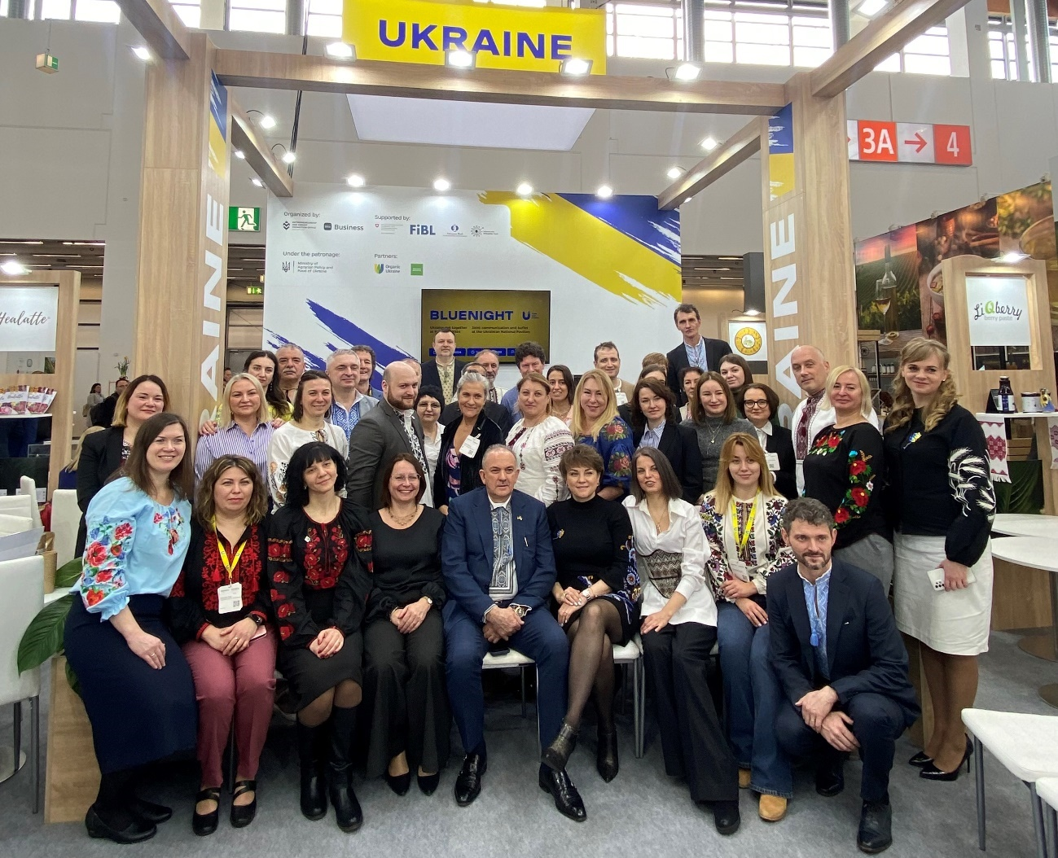

The 2024 Ukrainian delegation to Biofach. Photo: FiBL

(Frick, 11.02.2025) “The numbers from Ukraine are impressive: Despite the devastating impacts of Russia’s war of aggression, Ukraine recorded certified organic agricultural land in 2023 of almost half a million hectares” (471,176 ha) and an export volume of 198 thousand tons”, states “The World of Organic Agriculture 2025”, the annual statistics book of the organic sector, that was presented today at Biofach in Nuremberg.

According to the authors of the yearbook, “these figures demonstrate the resilience and adaptability of Ukrainian farmers, who continue to embrace organic farming even under the most challenging circumstances. However, there is a decline in exports, reflecting the severe logistical disruptions caused by the war.”

Nevertheless, Ukraine is still one of the Top 5 organic exporters to the EU, with Switzerland as the 4th largest importer of Ukrainian organic products. The total trade volume of Ukrainian organic exports in 2023 amounted to 141 million USD, while the value of the domestic market was 27 million USD.

FiBL mission shows serious challenges for producers and processors

A mission conducted in December 2024 by two FiBL experts confirmed the current challenges and opportunities faced by organic operators in Ukraine despite the ongoing war: tremendously increased costs, labour shortages, and logistical challenges. The mission by Toralf Richter and Nicolas Lefebvre was part of the ongoing Quality Food Trade Program (QFTP). This long-term program, financed by the Swiss State Secretariat for Economic Affairs SECO started in 2019 and is planned to run until 2026. An extension phase until 2028 is currently under discussion. Its main objective is to promote sustainable trade and more and better jobs by strengthening the business competitiveness and capacities of small and medium enterprises in the organic and dairy sectors in Ukraine, thereby contributing to sustainable and inclusive economic growth in Ukraine

In a FiBL Podcast published yesterday, Toralf Richter and Nicolas Lefebvre give a detailed account of their mission in December 2024 (see link below).

24 Ukrainian organic exporters at Biofach 2025

Despite the full-scale war that has been going on for nearly three years, the Ukrainian organic sector manages every year to grow and process innovative high-quality organic products in their fields and to market them successfully both in Ukraine and abroad. At Biofach, 24 Ukrainian organic exporters are offering their products at the large joint National Pavilion of Ukraine.

The congress at Biofach offers the additional opportunity to get an impression of the performance of Ukrainian organic companies and the current status of organic policy in Ukraine. Under the title “Ukraine's Organic Sector in the EU Integration Process – Challenges, Opportunities, and Post-War Resilience”, several representatives of trade and politics from Ukraine, Switzerland and the EU will provide information on the current situation in Ukraine, trade and legislative framework.

These include Taras Vysotskyi, First Deputy Minister of Agrarian Policy and Food of Ukraine; Jan Plagge, President of IFOAM Organics Europe; and Marianna Paolino, Team Leader International at the DG AGRI of the EU Commission.

A few key figures from the Ukrainian organic sector (2023)

* Organic agricultural land: 471,176 ha
* In conversion: 80,253 ha
* Organic share of total agricultural land 1.1 percent
* Number of agriproducers: 383
* Exports: 198,000 Metric tons

Source: The World of Organic Agriculture 2025 / QFTP

FiBL contacts

* Toralf Richter, Ukraine expert, FiBL Switzerland  
  Phone +41 62 865 04 25, e-mail [toralf.richter@fibl.org](mailto:toralf.richter@fibl.org)
* Adrian Krebs, Media spokesperson, FiBL Switzerland  
  Phone +41 62 865 50 32, e-mail [adrian.krebs@fibl.org](mailto:adrian.krebs@fibl.org)

QFTP is funded by

* State Secretariat for Economic Affairs (SECO), Switzerland

QFTP is implemented by

* FiBL Switzerland, in collaboration with SAFOSO AG, Switzerland

Podcast

FiBL produced a podcast about the mission of Toralf Richter and Nicolas Lefebvre in December 2024: <https://www.fibl.org/de/infothek/podcast/fibl-collaboration#c74100>

National Pavilion of Ukraine at Biofach 2025

Hall 4A, stand 625: 24 Ukrainian exporters will exhibit their organic products.

More information about the stand:  
<https://minagro.gov.ua/en/news/national-pavilion-of-ukraine-at-the-international-organic-products-exhibition-biofach-2025>   
<https://organicinfo.ua/en/news/biofach-2025-2/>  
The Catalogue of Ukrainian organic exporters 2025: <https://organicinfo.ua/wp-content/uploads/2025/02/Catalogue-of-Ukrainian-Organic-Exporters-2025.pdf>

Ukraine Session at Biofach Congress

February 12, 2pm, Room Shanghai, NCC Ost: “Ukraine's Organic Sector in the EU Integration Process – Challenges, Opportunities, and Post-War Resilience” (English/Ukrainian). Find the programme here: <https://organicinfo.ua/en/events/biofach2025-conference/>

Links

QFTP program website: <https://qftp.org/en/>   
QFTP in the FiBL project database: <https://www.fibl.org/en/themes/projectdatabase/projectitem/project/2410>

The World of Organic Agriculture

Download the statistical yearbook “The World of Organic Agriculture 2025”, including data for Ukraine <https://www.organic-world.net/yearbook/yearbook-2025.html>

This media release online

This media release and pictures can be accessed online at [www.fibl.org/en/info-centre/media.html](https://www.fibl.org/en/info-centre/media.html).

About FiBL

The Research Institute of Organic Agriculture FiBL is one of the world's leading research institutions in the field of organic agriculture. FiBL's strengths are interdisciplinary research, joint innovations with farmers and the food industry as well as rapid knowledge transfer. The FiBL Group currently includes FiBL Switzerland (founded in 1973), FiBL Germany (2001), FiBL Austria (2004), ÖMKi (Hungarian Research Institute of Organic Agriculture, 2011), FiBL France (2017) and FiBL Europe (2017), which is jointly supported by the five national institutes. More than 400 employees work at the various locations.   
Since 2005, FiBL successfully implements SECO-funded projects, supporting the organic sector in Ukraine.

[www.fibl.org](http://www.fibl.org)