Media release

What organic farming achieves for environment and society – meta-analysis provides comprehensive results

A review of over 500 scientific publications – a so-called meta-analysis – analyses the potential of organic farming. It shows that in many areas, organic farming results in lower environmental impacts than other forms of agriculture.

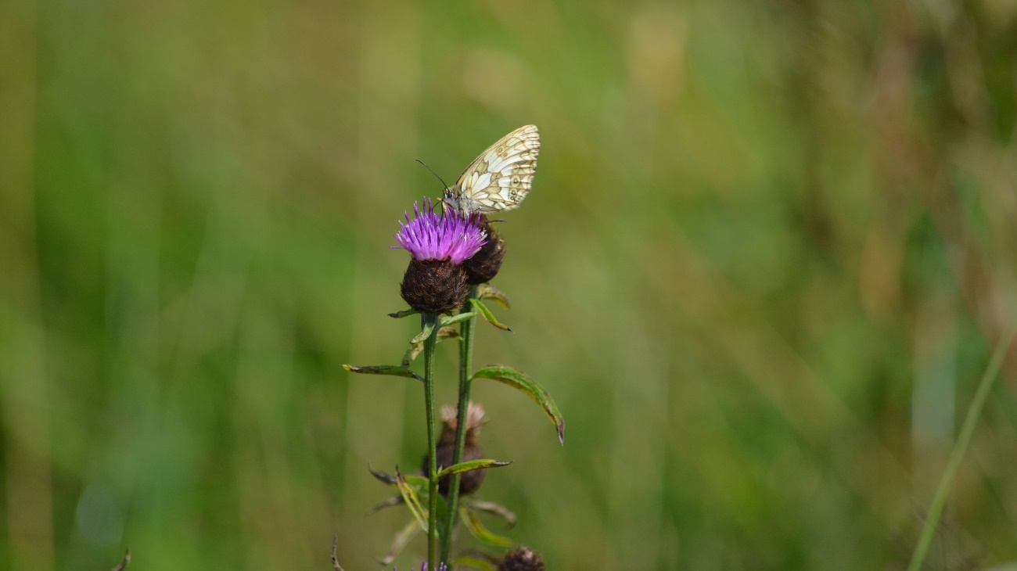

Organic farming has a positive impact on biodiversity: the number of species of arable flora   
(plus 95%), field birds (plus 35%) and flower-visiting insects (plus 23%) is significantly higher than in conventional production. Picture: FiBL, Simona Moosmann

(Frick, 08.04.2025) Organic farming is considered a sustainable form of agriculture and is therefore specifically promoted. However, there are different assessments of its potential in politics and science. In order to get a well-founded overview of the current state of knowledge and to evaluate the social services provided by organic farming in a differentiated way, a research consortium has evaluated the scientific literature on this topic.

The study paid particular attention to the areas of water protection, soil fertility, biodiversity, climate change mitigation and adaptation, resource efficiency, and animal welfare. The authors of the study evaluated 528 publications in which a total of 33 parameters were compared between organic and conventionally managed farms. The results have now been published in the international journal Organic Agriculture. On this occasion, Jürn Sanders, lead author and Chair of the FiBL Management Board, took a closer look at the results in a new FiBL Focus podcast (German only).

More earthworms and biodiversity – no clear trend for phosphorus

The study makes it clear that organic agriculture has great potential for protecting ground and surface water. The absence of synthetic chemical pesticides has a positive impact here. In the studies evaluated, organic farming also reduced nitrogen emissions by an average of 28 per cent.The advantages of organic farming are also apparent in soil fertility. The abundance and biomass of earthworm populations were, on average, 78 and 94 per cent higher, respectively. In 62 per cent of the comparisons, organic farming resulted in lower acidification in the topsoil. However, no clear trend could be identified for the plant-available phosphorus content.

Organic farming also has positive effects on biodiversity. For example, the mean species number of arable flora is increased by 95 per cent, that of field birds by 35 per cent and that of flower-visiting insects by 23 per cent.

Climate protection unclear, but positive in terms of resource consumption

The contribution of organic farming to climate protection is less clear. According to the evaluation, organic farms emit, on average, 1082 kg less CO2 equivalents per hectare and year due to a higher carbon storage rate and reduced nitrous oxide emissions. However, due to the lower yield levels in organic farming, the yield-related climate protection benefits are probably comparable to those of conventional agriculture.

The study results also emphasise that organic farming can contribute to the prevention of erosion and flood protection. The humus content and aggregate stability were, on average, 26 per cent and 15 per cent higher, respectively, in organic farming; a difference of 137 per cent was found for infiltration. This reduces surface runoff and soil erosion.

The economical use of resources in organic farming is reflected, among other things, in nitrogen and energy efficiency. In both areas, organic farming proved to be more advantageous. In crop farming, nitrogen efficiency was, on average, 12 per cent higher and energy efficiency 19 per cent higher than in conventional farming.

When it comes to animal welfare, management appears to be more important

No clear picture emerged for animal welfare. In 46 per cent of the comparison pairs, no clear differences were found between organic and conventional animal husbandry. The organic management approach showed advantages in 35 per cent of the comparison pairs, and the conventional approach in 19 per cent. No fundamental differences were found in animal health; management appears to be more decisive here than the farming method.

In addition to FiBL, the following institutions were also involved in the publication in the journal Organic Agriculture: the Thünen Institute, the University of Kassel, the Bavarian State Research Center for Agriculture, the Justus Liebig University Giessen, the Leibniz Centre for Agricultural Landscape Research, the Technical University of Munich and the Center for Applied Research and Technology at the Dresden University of Applied Sciences. The project was funded by the German Federal Ministry of Food and Agriculture (BMEL).

FiBL contacts

* Dr. Jürn Sanders, chairman of the management board, FiBL Switzerland  
  Phone +41 62 865 17 41, e-mail [juern.sanders@fibl.org](mailto:juern.sanders@fibl.org)
* Adrian Krebs, Media spokesperson, FiBL Switzerland  
  Phone +41 79 500 88 52, e-mail [adrian.krebs@fibl.org](mailto:adrian.krebs@fibl.org)

Links

* The Publication «Benefits of organic agriculture for environment and animal welfare in temperate climates» in the journal Organic Agriculture online: <https://rdcu.be/ec0mu>
* The podcast ‘What are the benefits of organic food? A look at over 500 studies’ (in German): <https://www.fibl.org/de/infothek/meldung/podcast-was-bringt-bio-blick-in-ueber-500-studien>
* The summary: in a nutshell – the social benefits of organic farming (in German): <https://orgprints.org/id/eprint/51949/1/sanders-etal-2023-UGOE_Schlussbericht-III.pdf>
* The project report on the study (in German): <https://www.thuenen.de/media/publikationen/thuenen-report/Thuenen_Report_65.pdf>

Reference

Sanders J., Brinkmann J., Chmelikova L., Ebertseder F., Freibauer A., Gottwald F., Haub A., Hauschild M., Hoppe J., Hülsbergen K., Jung R., Kusche D., Levin K., March S., Schmidtke K., Stein‑Bachinger K., Treu H., Weckenbrock P., Wiesinger K., Gattinger A., Hess J. (2025): Benefits of organic agriculture for environment and animal welfare in temperate climates. Organic Agriculture, published March 2025, open access. Received: 25 September 2024 / Accepted: 30 January 2025

This media release online

This media release and pictures can be accessed online at [www.fibl.org/en/info-centre/media.html](http://www.fibl.org/en/info-centre/media.html).

About FiBL

The Research Institute of Organic Agriculture FiBL is one of the world's leading research institutions in the field of organic agriculture. FiBL's strengths are interdisciplinary research, joint innovations with farmers and the food industry as well as rapid knowledge transfer. The FiBL Group currently includes FiBL Switzerland (founded in 1973), FiBL Germany (2001), FiBL Austria (2004), ÖMKi (Hungarian Research Institute of Organic Agriculture, 2011), FiBL France (2017) and FiBL Europe (2017), which is jointly supported by the five national institutes. More than 400 employees work at the various locations. [www.fibl.org](https://www.fibl.org/)