Media release

****Global organic area nears 99 million hectares – o****rganic market back on track

****Organic farming expands by 2.5 million hectares; global market grows to more than 136 billion euros****

(Frick/Bonn, February 11, 2025) The global organic farming area expanded by 2.6 percent in 2023, bringing the total to 98.9 million hectares, managed by 4.3 million organic producers. Retail sales of organic food also increased, exceeding 136 billion euros. These latest statistics, featured in the 26th edition of the yearbook *The World of Organic Agriculture*, will be presented by the Research Institute of Organic Agriculture FiBL and IFOAM – Organics International on Tuesday, February 11, 2025, from 5:00 to 6:00 PM at BIOFACH, the world's leading trade fair for organic food, held in Nuremberg, Germany.

Highlights from The World of Organic Agriculture

****Organic farmland increases by 2.5 million hectares****

* + By the end of 2023, 98.9 million hectares were managed organically, marking a 2.6 percent increase (+2.5 million hectares) from 2022.
  + Latin America experienced the largest increase, adding 1 million hectares (10.8 percent growth), while Africa recorded the highest relative growth, expanding by 24 percent to reach 3.4 million hectares.
  + Oceania remains the leading region for organic farming, with 53.2 million hectares, accounting for more than half of the global organic area. It is followed by Europe, which has 19.5 million hectares, and Latin America, with 10.3 million hectares.
  + By country, Australia leads with 53 million hectares, followed by India (4.5 million hectares) and Argentina (4 million hectares).

****Liechtenstein is the country with the highest organic area share****

* + Globally, 2.1 percent of agricultural land was managed organically in 2023.
  + Liechtenstein led with 44.6 percent of its agricultural land under organic management, followed by Austria (27.3 percent ) and Uruguay (25.4 percent).
  + A total of 22 countries reported that 10 percent or more of their agricultural land was organic.

****More than 2 million organic producers in India****

* + In 2023, there were 4.3 million organic producers worldwide.
  + India remains the country with the most organic producers (2.36 million).
  + Notable increases were observed in Vietnam, Sri Lanka, and Burkina Faso.

****Global market continued to grow; Switzerland tops per capita consumption****

* + The global market for organic products reached 136.4 billion euros in 2023. The European market recorded the strongest growth, with many countries recovering from the negative trend in 2022.
  + The United States retained its position as the largest market (59.0 billion euros), followed by Germany (16.1 billion euros) and China (12.6 billion euros).
  + Switzerland recorded the highest per capita spending on organic food (468 euros), while Denmark led with the largest organic market share (11.8 percent of its total food market).
  + Retail sales increased significantly in Estonia (+13.0 percent) and the Netherlands (+12.5 percent). The two largest markets – the United States and Germany experienced growth rates of 3.4 and 5.0 percent, respectively.

Organic farming remains on a successful path: In 2023, organic farming continued to expand, with increases in cultivated land, markets, and international trade—albeit at a moderate pace. Africa showed particularly dynamic growth, with a significant increase in organic farmland, while some European markets recorded double-digit growth rates. The market has recovered noticeably, and the numbers speak for themselves: the importance of organic farming continues to grow steadily.

****Publication and data****

The yearbook, jointly published by FiBL and IFOAM – Organics International, is supported by the Swiss State Secretariat for Economic Affairs (SECO), the Coop Sustainability Fund, Bio Suisse and NürnbergMesse, the organiser of BIOFACH. Data was collected from 188 countries.

Contacts

* Helga Willer, Research Institute of Organic Agriculture FiBL  
  Ackerstrasse 113, 5070 Frick, Switzerland  
  Phone +41 79 218 06 26  
  [helga.willer@fibl.org](mailto:helga.willer@fibl.org), [www.fibl.org](https://www.fibl.org)
* Ravi R. Prasad, IFOAM – Organics International,   
  Charles-de-Gaulle-Strasse 5, 53113 Bonn, Germany  
  [r.prasad@ifoam.bio](mailto:r.prasad@ifoam.bio), [www.ifoam.bio](https://www.ifoam.bio)

This media release online

This media release and graphs can be accessed online at <https://www.fibl.org/en/info-centre/media.html>.

Download *The World of Organic Agriculture*

The yearbook can be downloaded at [https://shop.fibl.org](https://shop.fibl.org/) (item number 1797).

Graphs and infographics (see also following pages) can be downloaded at <https://www.organic-world.net/yearbook/yearbook-2025.html>.

**About FiBL**  
The Research Institute of Organic Agriculture FiBL is one of the world’s leading institutes in the field of organic agriculture. FiBL’s strengths lie in its interdisciplinary research, innovations developed jointly with farmers and the food industry, and rapid knowledge transfer. The FiBL Group currently includes FiBL Switzerland (founded in 1973), FiBL Germany (2001), FiBL Austria (2004), ÖMKi (Hungarian Research Institute of Organic Agriculture, 2011), FiBL France (2017) and FiBL Europe (2017), which is jointly supported by the five national institutes. FiBL employs more than 400 staff at its various locations.

[www.fibl.org](https://www.fibl.org/)

Sessions at BIOFACH

Session “The World of Organic Agriculture – Latest Statistics”

Tuesday, February 11, 2025, 5 to 6 pm, Room Shanghai (NCC East), Forum Biofach, BIOFACH Congress, NürnbergMesse

* + Ravi Prasad, IFOAM - Organics International: Facilitator
  + Helga Willer, Forschungsinstitut für biologischen Landbau FiBL, Switzerland
  + Gábor Figeczky, IFOAM - Organics International, Bonn, Germany
  + Marco Kräuchi, State Secretariat for Economic Affairs SECO, Switzerland
  + Amarjit Sahota, Ecovia Intelligence, London, UK

Info: <https://biofach.fibl.org/en/biofach-all/biofach-2025#c75786>

Session “Global Organic Market Overview” on February 12, 2025

Wednesday, February 12, 2025, 3:00 to 4:30 pm CET, Room St Petersburg (NCC East), Forum Biofach, BIOFACH Congress, NürnbergMesse

* + Ravi R. Prasad, Director, IFOAM – Organics International: Facilitator
  + Helga Willer, Scientist, FiBL - Research Institute of Organic Agriculture, Switzerland
  + Eduardo Cuoco, Director, IFOAM Organics Europe, Brussels, Belgium
  + Joanna Wierzbicka, Deputy Director, IFOAM Organics Europe, Brussels, Belgium
  + Thales Mendonça, Global Relationship Manager, Inter-Continental Network of Organic Farmer Organisations (INOFO)
  + Tom Chapman, CEO, Organic Trade Association, USA
  + Tia Loftsgard, Executive Director, Canada Organic Trade Association, Canada
  + Josefine Pettersen, Operations and Technical Manager, Australian Organic Limited, Australia
  + Youting Zhang, Executive Vice President, Organic and Beyond Corporation, China

Info: <https://biofach.fibl.org/en/biofach-all/biofach-2025#c75776>

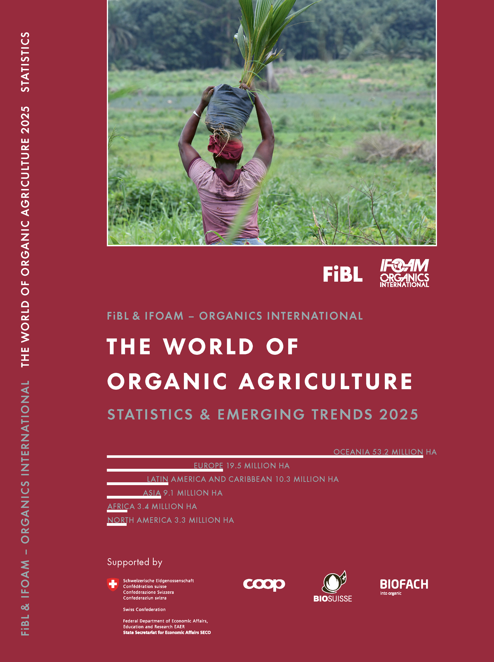Yearbook "The World of Organic Agriculture" at a glance

The yearbook "The World of Organic Agriculture - Statistics and Emerging Trends 2025" (350 pages) presents the results of the annual survey on organic agriculture worldwide and has numerous tables, graphs, maps and infographics. It contains reports by experts on the organic sector and information on emerging trends across all regions as well as selected countries. It also provides background information on standards and legislation, policy support, and the global market for organic food.

Further information and download link are available at [www.organic-world.net/yearbook/yearbook-2025.html](http://www.organic-world.net/yearbook/yearbook-2025.html).

Data collection

The data on organic agriculture is collected annually by FiBL in collaboration with many partners from around the world. The results are published jointly with IFOAM – Organics International. The activities are supported by the Swiss State Secretariat of Economic Affairs SECO, the Coop Sustainability Fund, Bio Suisse and NürnbergMesse, the organiser of the BIOFACH trade fair.

Book citation

Willer, Helga, Jan Trávníček and Bernhard Schlatter (Eds.) (2025): The World of Organic Agriculture. Statistics and Emerging Trends 2025. Research Institute of Organic Agriculture FiBL, Frick, and IFOAM – Organics International, Bonn. Available at [www.organic-world.net/yearbook/yearbook-2025.html](http://www.organic-world.net/yearbook/yearbook-2025.html).

Where to download

The book can be downloaded at <https://shop.fibl.org> (order number 1797).

Online database and interactive infographics

The data is available online at <https://statistics.fibl.org>.

**Organic Agriculture: Key Indicators and Top Countries**

| **Indicator** | **World** | **Top countries** |
| --- | --- | --- |
| **Countries with organic activities** | 2023: 188 countries |  |
| **Organic agricultural land** | 2023: 98.9 million hectares  (2000: 15 million hectares) | Australia (53.0 million hectares) India (4.5 million hectares) Argentina (4.0 million hectares) |
| **Organic share of total agricultural land** | 2023: 2.1 % | Liechtenstein (44.6 %) Austria (27.3 %) Uruguay (25.4 %) |
| **Increase of organic agricultural land 2022/2023** | 2.5 million hectares (ha); +2.6 % | Uruguay: 831'287 ha (+30.3 %)  China: 522'267 ha (+18.0 %) Spain: 316'550 ha (+11.8 %) |
| **Wild collection and further non-agricultural areas** | 2023: 30.2 million hectares (1999: 4.1 million hectares) | Finland (6.9 million hectares) China (2.9 million hectares) India (2.9 million hectares) |
| **Producers** | 2023: 4.3 million producers  (1999: 200’000 producers) | India (2'358'267) Uganda (404'246) Ethiopia (121'552) |
| **Organic market** | 2023: 136.4 billion euros (2000: 15.1 billion euros) | US (59.0 billion euros) Germany (16.1 billion euros) China (12.6 billion euros) |
| **Per capita consumption** | 2023: 17.0 euros | Switzerland (468 euros)  Denmark (362 euros) Austria (292 euros) |
| **Number of countries/ territories with organic regulations (2022)** | 75 (fully implemented)  14 (drafting) |  |
| **Number of affiliates of IFOAM – Organics International** | 2023: 857 affiliates | Germany: 87 affiliates India: 58 affiliates China: 54 affiliates USA: 53 affiliates Italy: 32 affiliates |

Source: FiBL survey 2025, based on national data sources, data from certifiers and IFOAM – Organics International

Infographics

