Media release

Growing together: competence centre for Swiss plant breeding

Climate change and new diseases call for new varieties adapted to Switzerland. FiBL Switzerland, Agroscope, ETH Zurich, Sativa Rheinau AG and Delley Seeds and Plants Ltd have initiated the Swiss Plant Breeding Centre (SPBC) and founded an association with Swiss plant breeders to bring these to market more quickly. The main tasks of the SPBC are to implement new findings and techniques in practical plant breeding and to network stakeholders.

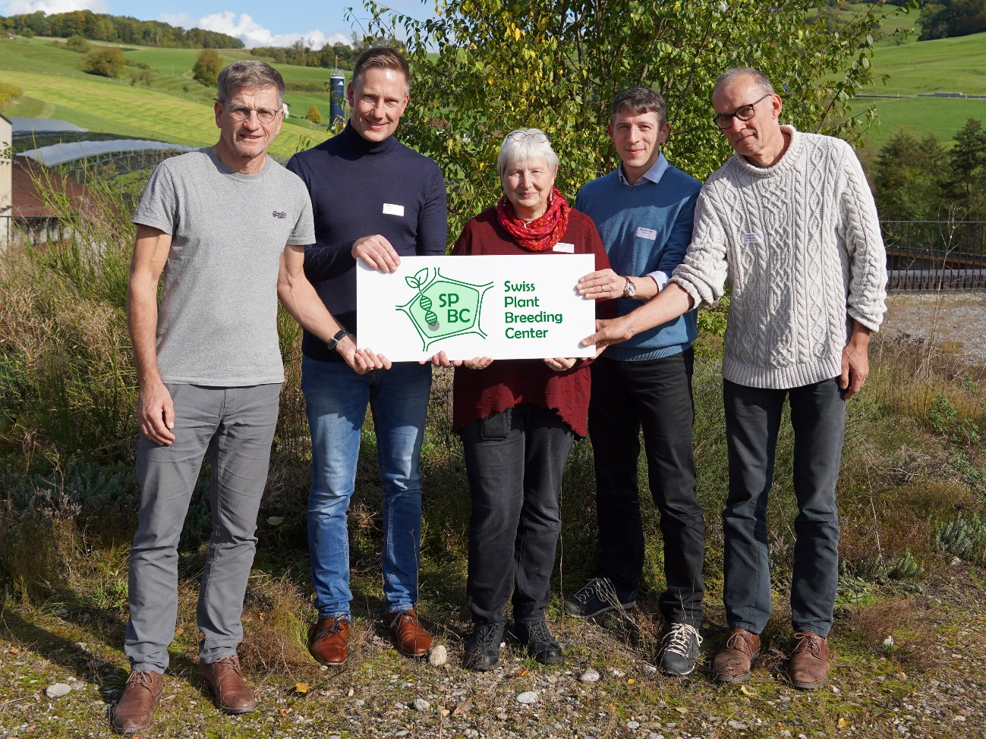

The Board of Directors of the association responsible for the Swiss Plant Breeding Centre. From left to right: Karl-Heinz Camp, Delley Seeds and Plants Ltd, Bruno Studer, ETH Zurich, Monika Messmer, FiBL Switzerland, Roland Peter, Agroscope, Amadeus Zschunke, Sativa Rheinau AG. (Photo: FiBL, Andreas Basler)

(Frick, 11.10.2024) The association responsible for the Swiss Plant Breeding Centre (SPBC) was founded today at FiBL Switzerland in Frick. The SPBC is an independent competence and innovation network that supports both public and private Swiss plant breeders in developing robust varieties that are adapted to Swiss production and market conditions.

Response to acute challenges in plant breeding

Climate change, new plant diseases and pests are current challenges for which farmers are dependent on new robust varieties. Switzerland, with its different altitudes and cultivation systems, also has special requirements that are being taken into account less and less by international breeding companies. Swiss plant breeding is therefore a basic prerequisite for a sustainable and resilient food system. Since 2015, breeding expert Monika Messmer from FiBL Switzerland, together with other breeding experts, has been campaigning for a platform to strengthen Swiss plant breeding. She played a key role in the founding of the SPBC. "Thanks to the SPBC, the efficiency of public and private Swiss breeding will be improved and new techniques can be implemented more quickly," says Messmer.

Gap in the implementation of new research findings

The federal government's Plant Breeding Strategy 2050 has shown that there is a gap in the implementation of new research results in practical plant breeding. In this area, breeding companies in Switzerland often lack the necessary infrastructure, expertise and innovative strength. The Federal Office for Agriculture therefore supports the SPBC with the aim of strengthening Swiss plant breeding and increasing breeding efficiency. The main tasks of the SPBC are to transfer new research results into practical breeding programmes and to network the players in breeding and research.

Tailored to Swiss conditions

The aim of the SPBC is to close the gaps in Switzerland's mostly small plant breeding programmes. To this end, Swiss breeders are to be supported efficiently and competently in the implementation of results from applied research in their current breeding programme within the framework of innovation projects. This includes, for example, the agronomic and genetic characterisation of breeding material (phenotyping, genotyping), the use of marker-assisted selection and the use of large amounts of data in the breeding programme (databases, data analysis, bioinformatics, biostatistics). New genetic engineering methods are also included, provided they are authorised for use in Switzerland. The SPBC tailors its services to the needs of its customers, is open to all crop types, cultivation systems and methods and covers a wide range of expertise through network partnerships.

The SPBC has already picked up speed

The project partners for the founding of the SPBC are FiBL Switzerland, Agroscope, ETH Zurich, Sativa Rheinau AG and Delley Seeds and Plants Ltd. The office was staffed at the end of 2023 with the following employees:

* Azeddine Si Ammour, Managing Director
* Mathieu Deblieck, research assistant

The office is responsible for the operational activities of the SPBC. It provides breeders with technical support, know-how and expertise and is actively involved in the planning and implementation of seven innovation projects submitted by Swiss breeders. The SPBC is active in customer and third-party funding acquisition and promotes synergies between private and public breeders as well as cooperation between breeding research, practical plant breeding and other players in the downstream value creation process at the national and international level.

Association and Board of Directors with representation of Swiss plant breeders

The association aims to promote crop plant breeding in Switzerland and is also the responsible association of the SPBC. Active members of the association are Swiss breeders and breeding researchers as well as supporting members of the downstream value chain (seed, production, processing, trade). The Board of Directors of the new association was appointed on the same day as its foundation. It is made up of two private breeders, a public breeding representative, a breeding researcher and a researcher:

* Karl-Heinz Camp, Delley Seeds and Plants Ltd, Delley, Switzerland
* Amadeus Zschunke, Sativa Rheinau AG, Rheinau, Switzerland
* Roland Peter, Agroscope, Reckenholz, Switzerland
* Monika Messmer, FiBL, Frick, Switzerland
* Bruno Studer, ETH Zurich, Zurich, Switzerland

The Board of Directors is responsible for the strategic direction of the SPBC in accordance with the Plant Breeding Strategy 2050, and represents the sponsoring organisation externally to the public and plant breeding stakeholders.

FiBL contacts

* Monika Messmer, Breeding specialist FiBL Switzerland  
  Phone +41 62 865 04 25, e-mail [monika.messmer@fibl.org](mailto:monika.messmer@fibl.org)
* Franziska Hämmerli, Media spokesperson FiBL Switzerland  
  Phone +41 62 865 72 80, e-mail [franziska.haemmerli@fibl.org](mailto:franziska.haemmerli@fibl.org)

Support

* Federal Office for Agriculture, Switzerland [www.blw.admin.ch](https://www.blw.admin.ch/blw/en/home.html)  
  (as part of the Swiss Plant Breeding Strategy 2050)

Partner

* Agroscope [www.agroscope.ch](https://www.agroscope.admin.ch/agroscope/en/home.html)
* ETH Zurich [ethz.ch](https://ethz.ch/en.html)
* Sativa Rheinau AG [www.sativa.bio](https://www.sativa.bio/de_ch/)
* Delley Seeds and Plants Ltd [www.dsp-delley.ch](http://www.dsp-delley.ch)

Links

* Website of the Swiss Plant Breeding Centre (SPBC):  
  [www.spbc-plantbreeding.ch](https://www.spbc-plantbreeding.ch/en/spbc)
* List of funded projects:  
  [www.spbc-plantbreeding.ch/en/innovation-projects](https://www.spbc-plantbreeding.ch/en/innovation-projects)
* Swiss Plant Breeding Strategy 2050:  
  [www.blw.admin.ch/blw/en/home/nachhaltige-produktion/pflanzliche-produktion/pflanzenzuechtung.html](https://www.blw.admin.ch/blw/en/home/nachhaltige-produktion/pflanzliche-produktion/pflanzenzuechtung.html)

This media release online

This media release and pictures can be accessed online at [www.fibl.org/en/info-centre/media.html](https://www.fibl.org/en/info-centre/media.html).

About FiBL

The Research Institute of Organic Agriculture FiBL is one of the world's leading research institutions in the field of organic agriculture. FiBL's strengths are interdisciplinary research, joint innovations with farmers and the food industry as well as rapid knowledge transfer. The FiBL Group currently includes FiBL Switzerland (founded in 1973), FiBL Germany (2001), FiBL Austria (2004), ÖMKi (Hungarian Research Institute of Organic Agriculture, 2011), FiBL France (2017) and FiBL Europe (2017), which is jointly supported by the five national institutes. More than 400 employees work at the various locations. [www.fibl.org](https://www.fibl.org/)